Red Phone Icon Images – Browse 135,006 Stock Photos, Vectors, and Video |  Adobe Stock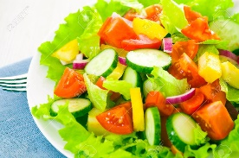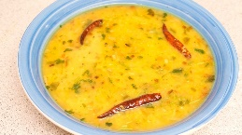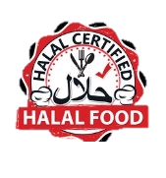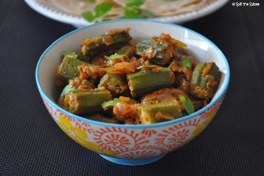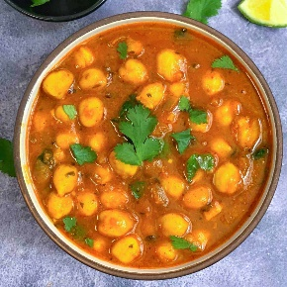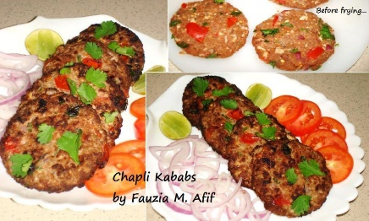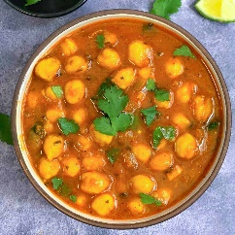

**9023 Annapolis Rd, Lanham, MD 20706**

240-828-8837. 202-430-4274.

* Chicken Biryani
* Chana Masala

Or Dall Tarka

* Chicken Chapli Kabab
* Vegetable (Bendy or Tendy)
* Salad
* Naan (1)

**Al-Madina Restaurant**

**Dinning, Catering and**

**Event Halls are Available**

**Buffet**

**only $9.99/Lb**



**Al-Madina Restaurant**

**Al-Madina Restaurant**

**Buffet $8.99/Lb**

**Dinning, Catering and**

**Event Halls are Available**

De BBQ 2Night servers traditional Indian, Pakistani and Afghani dishes with a festive flair. Each major region of India’s, Pakistan’s and Afghanistan’s diverse cuisines are adequately represented in our menu. Our dishes are authentic but served with a twist.

In addition to our menu, we serve an on-the-go menu line for our young customers. Come enjoy the De BBQ 2Night experience in our beautiful and spacious dining room with a great ambiance and an amazing view of the tempting food we serve.



* Vegetable
* Chicken Biryani
* Chana Masala
* Chicken Chapli Kabab
* Dall Tarka
* Salad
* Naan

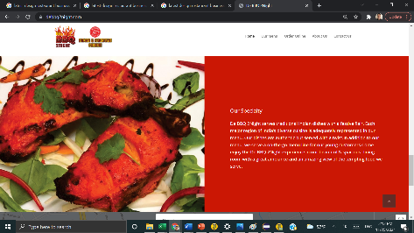

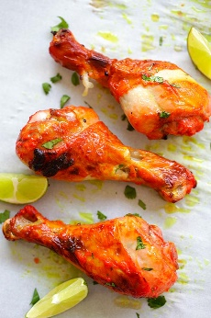

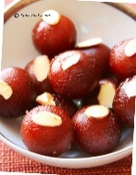

**9023 Annapolis Rd, Lanham, MD 20706**

240-828-8837. 202-430-4274.

**9023 Annapolis Rd, Lanham, MD 20706**

240-828-8837. 202-430-4274.

**Bread from Tandoori**

1. Naan
2. Garlic Naan
3. Sesame Naan
4. Mint Naan
5. Chile Naan
6. Tandoori Roti
7. Double Kabuli Naan
8. Double Peshawary Naan

**Salad**

1. House Salad
2. Chicken Salad
3. Yogurt Salad

**Breakfast**

1. Vegetable Omelet

51. Chicken Omelet

1. Beef Omelet
2. Halwa Puri

**Deserts**

1. Gulab Jamin
2. Mango Mousse
3. Ras Mallai
4. Gajar Halwa
5. Baghlava
6. Jelibee
7. Keer

**Drinks**

1. Water
2. Soft Drinks
3. Mango Lassi
4. Juice
5. Milk
6. Yogurt
7. Karak Chai
8. Black Tea
9. Green Tea
10. Coffee

**Appetizers**

1. Samosa
2. Pakora
3. French Fries
4. Buffalo Wings
5. Papari Chaat
6. Samoa Chaat
7. Dhai Ballee
8. Shorma
9. Soup (Vege, Chicken & Lentin)

**Specialty**

1. Butter Chicken
2. Chicken Tikka Masala
3. Kofta Meatballs
4. Chicken Vindaloo

**Vegetarian**

1. Palak Paneer
2. Chana Masala
3. Malai Kofta
4. Daal Tarka
5. Daal Makhani
6. Vegetable Korma
7. Okra Masala (Bendy)

**BBQ Tikka**

1. Chicken Tandoori (Half/Full)
2. Chicken Tikka
3. Beef Chaplee Kabab
4. Chicken Chaplee Kabab
5. Fish Kabab
6. Lamb Chops
7. Chicken Seekh
8. De BBQ 2Night Special Combo
9. De BBQ Special Grill Platter

**Work Specialties**

1. Chicken Biryani
2. Goat Biryani
3. Vegetable Biryani
4. Qabuli Palaw
5. Chicken Karahi
6. Chicken Karee
7. Goat Karahi
8. Goat Karee
9. Nehari

